**CS407 Project Assignment – App: BudgetBuddy**

Short Description: A user-friendly budgeting assistant for managing personal and household finances effectively.

**Team Members**

* Qiming Zhang
  + UW Email: [qzhang478@wisc.edu](mailto:qzhang478@wisc.edu)
  + GitHub ID: terry-qmzhang
* Sky Lu
  + UW Email: [tlu83@wisc.edu](mailto:tlu83@wisc.edu)
  + GitHub ID: lutianyu2001
* Sanjana Golla
  + UW Email: [ssgolla@wisc.edu](mailto:ssgolla@wisc.edu)
  + GitHub ID: sanjuGolla1

**Wireframe and Natural Users Feedback**

**Wireframe**

Link to figma: <https://www.figma.com/design/ZD3uVlEWfoVXlKfeLUBfLK/CS407-Wireframe?node-id=22-183&t=8iwMQyuGEaLrm2Uq-1>

(See next page for preview)

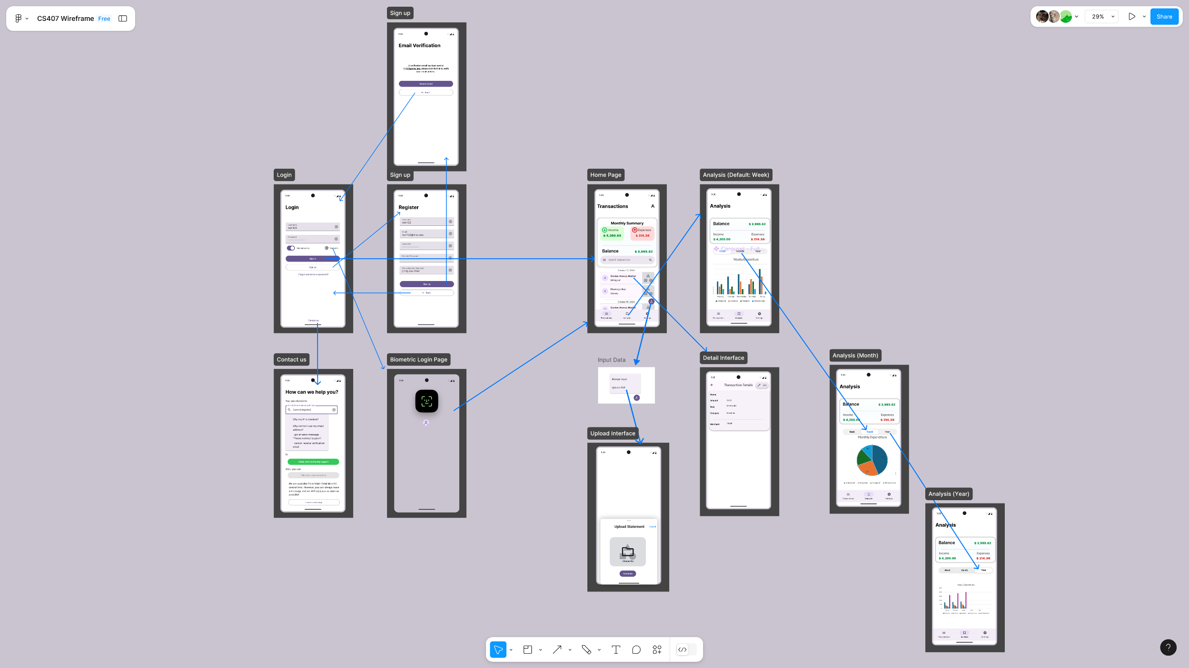

**Natural Users Feedback**

1. User 1 An undergraduate student:

It seems like it could be pretty useful for students like me. The simple layout in the wireframe looks easy to navigate, which is great since I don't want to spend ages learning how to use an app.

I like the idea of getting alerts if I go over budget. That could really help me avoid overspending on stuff like takeout or online shopping. The monthly summary report sounds good as it'd be helpful to see where all my money's going.

One thing I'm wondering about is how easy it'll be to input expenses. Will I have to manually enter everything, or is there a way to automate it? Also, it'd be cool if you could add a feature for splitting costs with roommates. That's always a headache for us.

Overall, it looks promising. I'd be interested in trying it out once it's up and running!

1. User 2 An graduate student:

The wireframe looks clean and straightforward, which I appreciate. The graphs on the analysis pages look like they could be really helpful for visualizing spending patterns. I'm curious about how detailed these will be in the actual app.

The biometric login feature is a nice touch for security. I'm a bit concerned about connecting it to bank accounts though. How secure will this be? Maybe you could explain more about the safety measures in place.

One thing I didn't see in the wireframe: will there be a way to set savings goals? That would be super useful for people like me who are trying to save up for big purchases or build an emergency fund.

**Milestones**

**October 28, 2024**

* Mobile App:
  + Complete user interface design
  + Implement user registration and login screens
  + Create basic dashboard layout
* Backend:
  + Set up database structure
  + Implement user authentication API

**November 11, 2024**

* Mobile App:
  + Implement income and expense tracking features
  + Create budget setting functionality
  + Develop basic data visualization for financial health
* Backend:
  + Implement API endpoints for income and expense tracking
  + Create data storage and retrieval system for user financial data

**November 25, 2024**

* Mobile App:
  + Implement notifications system for budget alerts
  + Develop monthly summary report generation
  + Integrate with sample bank backend for transaction history
* Backend:
  + Implement notification system
  + Create API for generating monthly summary reports
  + Develop sample bank backend with mock transaction data

**December 11, 2024**

* Mobile App:
  + Implement location-based budgeting feature
  + Add biometric authentication
  + Conduct thorough testing and bug fixes
* Backend:
  + Finalize all API endpoints
  + Implement data backup and multi-device sync
  + Conduct security audits and performance optimizations
* Other Components:
  + Complete user documentation
  + Prepare app for deployment on app stores

**Response to Comments**

N/A